Amdocs IDE Plug-In Project:
Method and Interface Editor

In this project, you will create an Amdocs IDE plug-in that includes two tightly integrated editors: an editor for interface objects (.interface files) and an editor for method objects (.methods files).

Important Note

Amdocs IDE is based on Eclipse, and therefore, this assignment can be solved using “pure” Eclipse plug-in development style. However, you are expected to use the Amdocs-specific support classes (e.g., ADEPlugin, ADEFormEditor, etc.) presented in class in your solution.

GUI screenshot: selecting the wizard
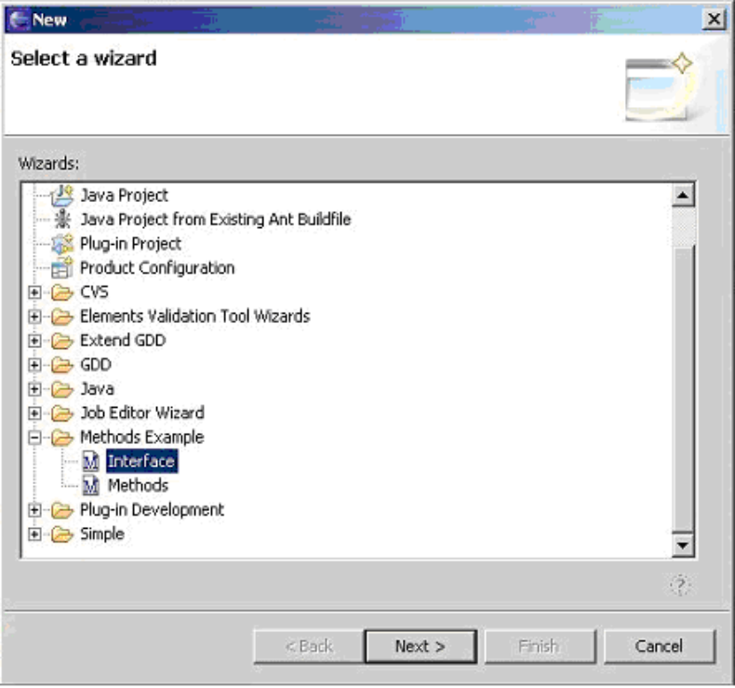

Step 1: Creating the Interface Wizard and Editor

The Interface wizard is a multipage wizard used for creating new .interface files. It has two pages:

- Select the Container (including a Browse button), and the new interface's name.

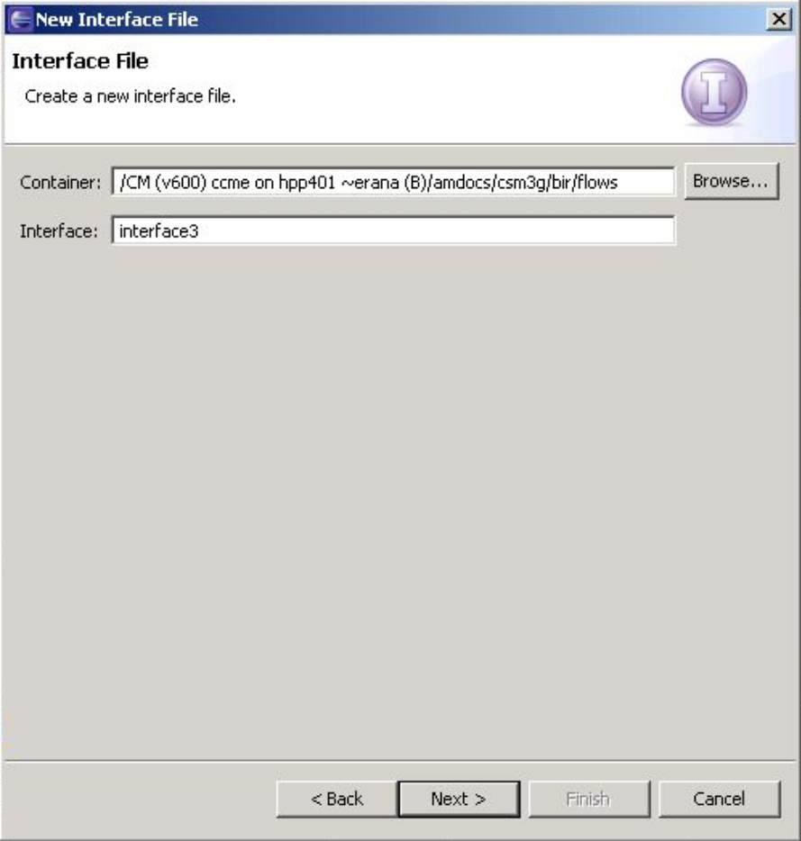
The Wizard's first page.

- The General Information page, including:
  - A checkbox specifying if the new interface extends an existing one.
  - An input box for selecting the extended (existing) interface. This box is disabled if the checkbox is unchecked.
  - A button for selecting an existing interface from the list (this button is disabled at this stage).
  - A Description input box.

Challenge for advanced developers: Have the Description input box have two tabs, "Text", where the users can type in HTML text, and "Preview", which shows the resulting HTML.

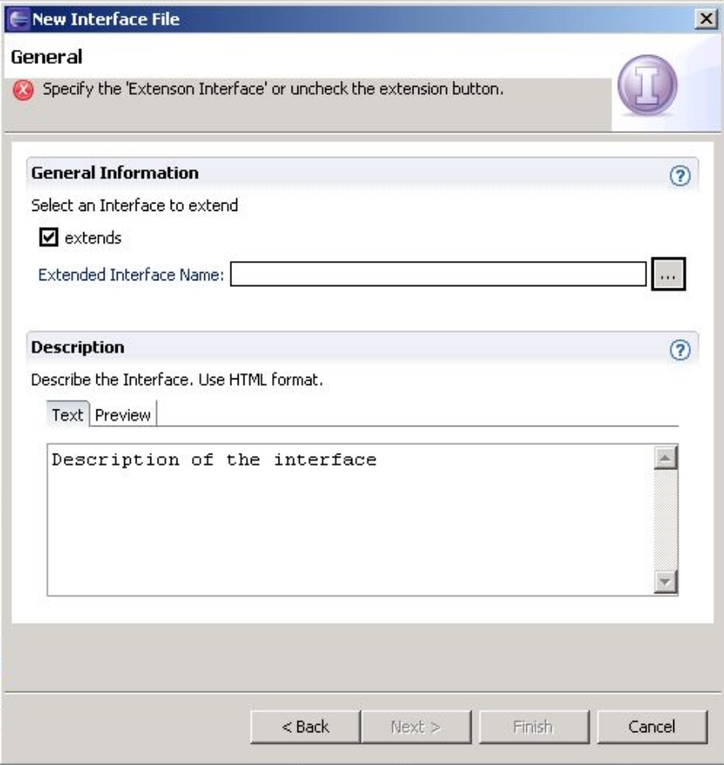
The wizard's second page (with the suggested advanced feature).

Clicking Finish in the wizard will automatically launch the editor.

The Interface editor is a multipage editor for editing such files, once they are created.

As per the standard Amdocs development model:
- Pages are shared between the wizard and the editor.
- The last page of the editor contains a non-editable source view.
- The editor/wizard pages should use the standard Amdocs validation model.

The editor's main page:

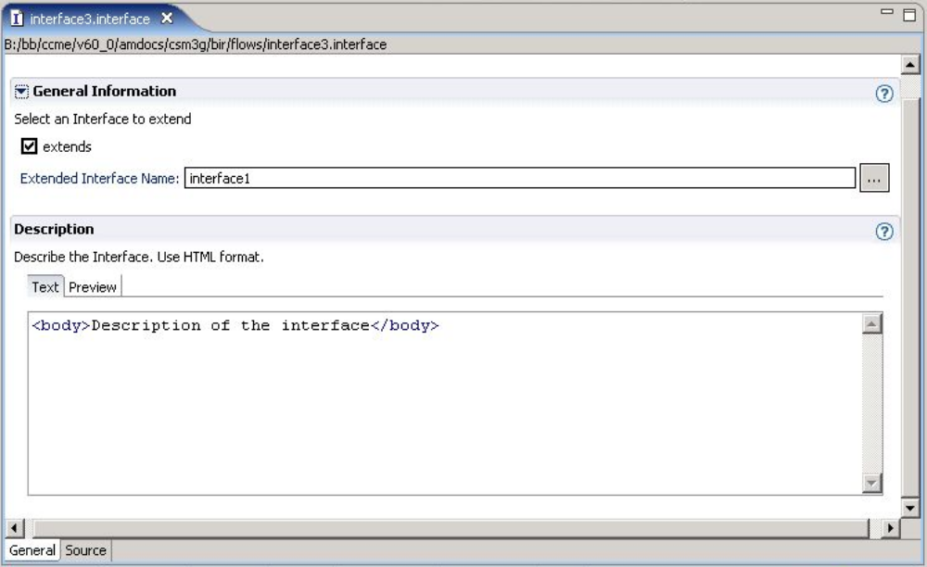

The editor's source page:

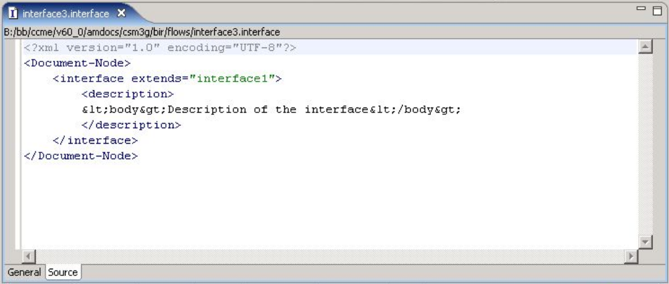
Step 2: Creating the Method Wizard and Editor

The Methods wizard is a multipage wizard used for creating new .methods files. Similar to the Interface wizard, it has two pages, shown in images below:

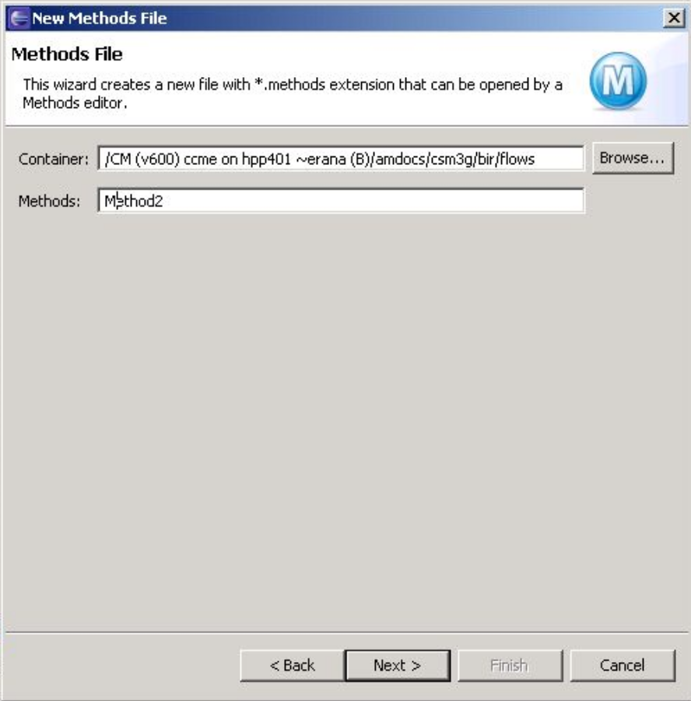
The wizard's first page: select the method to create.

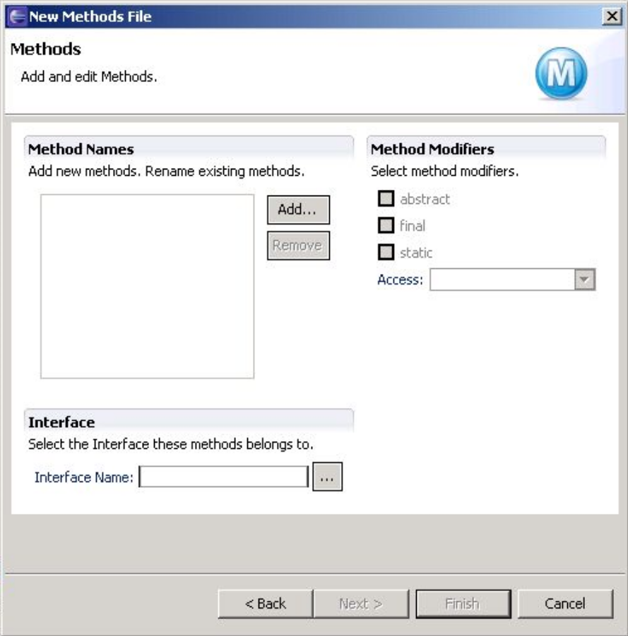
The wizard's second page: main details.

The main details page allows the user to add multiple methods to an existing interface. For each method, the user can specify if it is abstract, final, and/or static using a set of checkboxes. The access level, also set independently per method, can be "private", "public", "protected", or "default".

The "Add" button pops up a method-name input dialog:

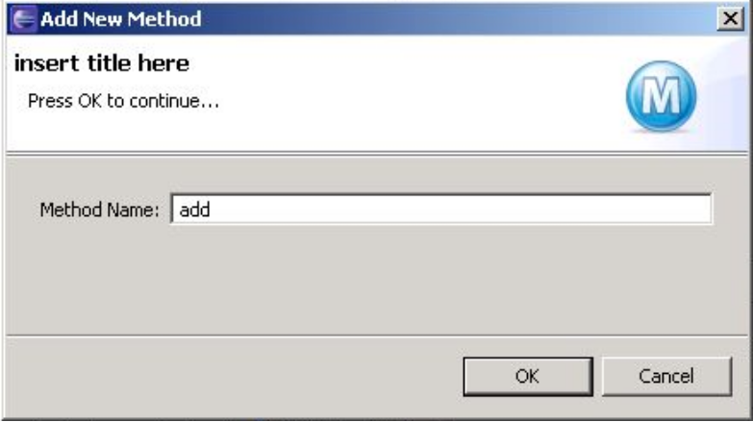

The "Remove" button removes the selected method (or methods) from the list.

Finally, the user must select an existing interface to which these methods will be added. The "..." button is disabled at this stage.

A completed form could look like this:

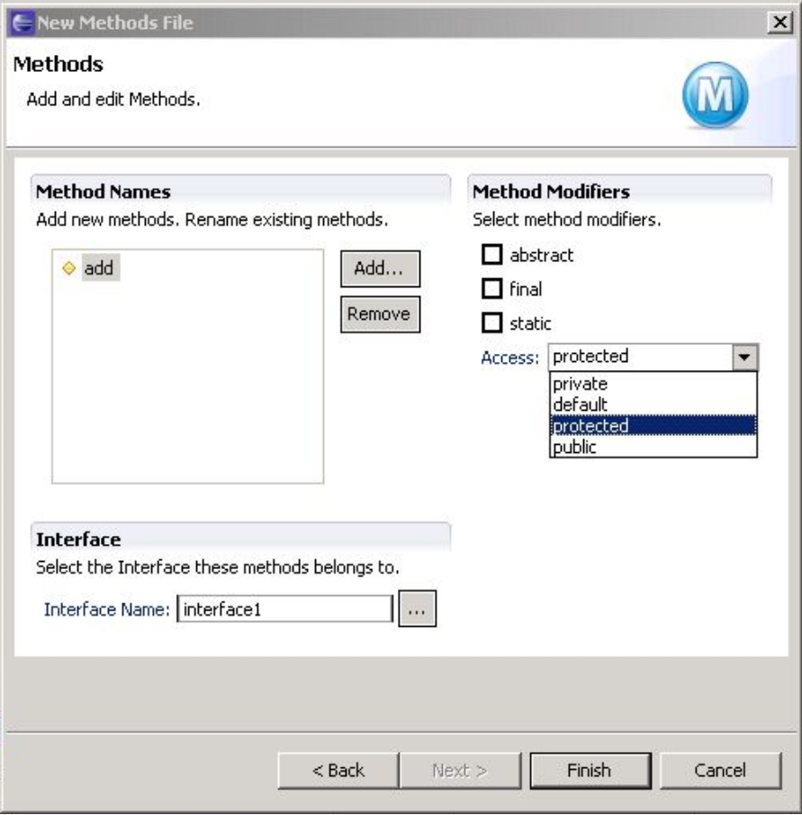

The Methods editor contains two pages:

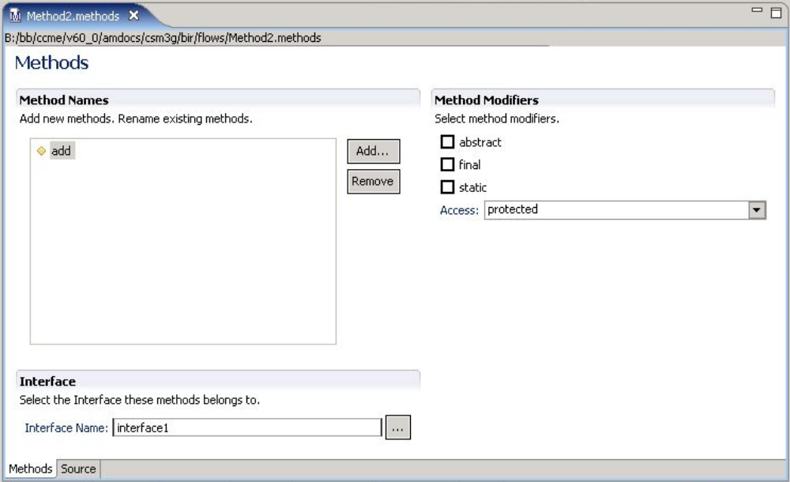
The main page.

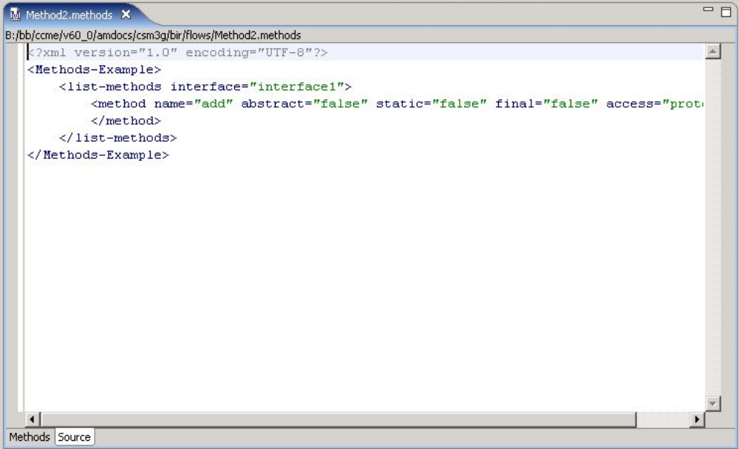
The (read-only) source page.
Step 3: Providing an Outline for Methods Files

Once the methods editor is completed, we wish to provide an Outline view for it:

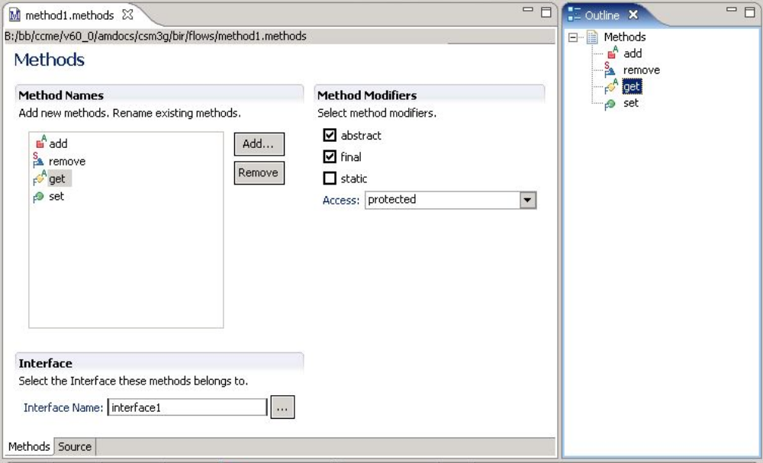

Note that this is the standard Eclipse Outline view, but it is now "aware" of Methods files and can display their content.

The outline view is linked with the editor, both in the mainand in the source page:

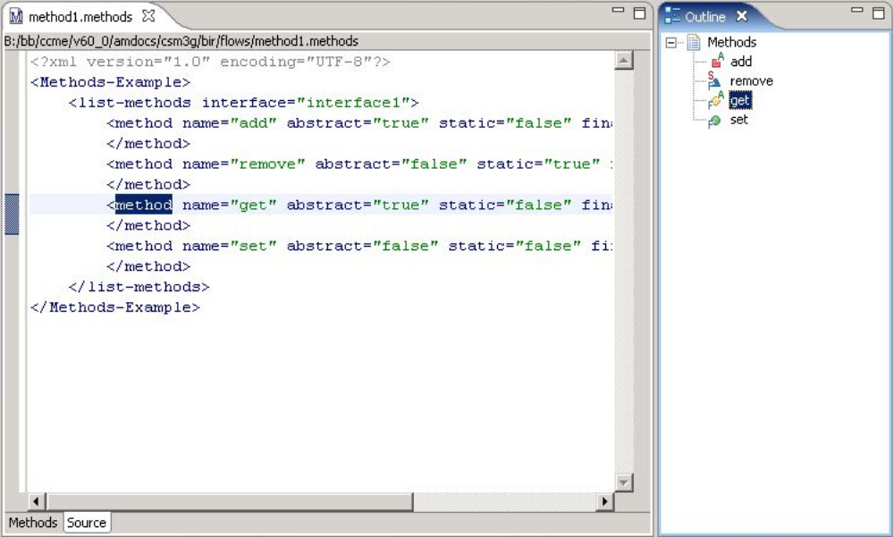
Step 4: Integrating with the Indexer

As the last step, we would like the Indexer to support .methods and .interface files. To this end, we use the com.amdocs.studio.indexer.indexParser extension point described in class.

Once indexing support is complete, we can also enable the previously-disabled "..." buttons in the Interface wizard and in the Methods wizard/editor. This button will pop-up a browser, using the com.amdocs.studio.indexer.ui.indexerUI extension point. The browser window should look like this:

